Chapter 7 Elements
extra worksheet 2: Mixtures

Answers
1
Mixture | Dispersion medium | Dispersed phase
a salt water | water | salt
b smoke from a fire | air | ash
c muddy water | water | sand
d fog | air | water
e whipped cream | cream | air

2 Possible answers include:
 |  | Dispersion medium
Dispersed phase |  | solid | liquid | gas
Dispersed phase | solid | brass alloy | sugar solution | smoke
Dispersed phase | liquid | gelatin | vinegar | a cloud
Dispersed phase | gas | sponge | shaving foam | air

3
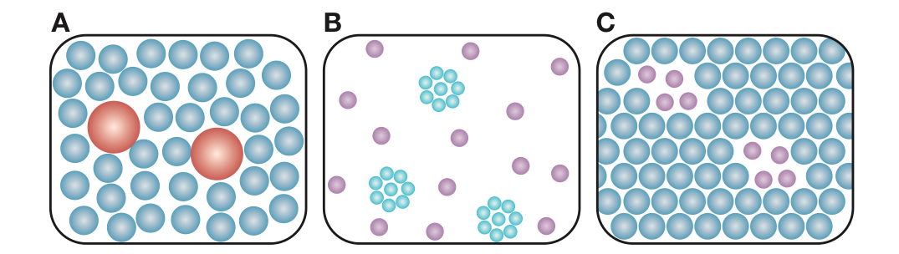
4


